**Homework 2 MJ2424**

**Joakim Ginste 19970614-7155**

**Question 1:**

The maximum timestep for each method is given by finding the stability limits and solving the maximum time step (dt) from the Fourier number (Fo). For Euler method dt = 5.162, when dx = dy = 0.0125 m. Whilst for Rungekutta 4 method it is instead dt = 3.19m when dx = dt = 0.0125m. These values were manually found in MATLAB by adding a small value of dt until the function stop giving answer, in other words stopped being stable.

The difference between the direct method and the method using time stepping is given below for both Euler and Rungekutta 4, when using the time step value that gives the lowest number of iterations, these values were also obtained by trying until the lowest amount of iterations is achieved for the toleration value of 10^-5.

|  |  |  |
| --- | --- | --- |
| Difference from direct method | Euler (dt = 4.47) | Rungekutta4 (dt =2.753) |
| Point 1 | 5.184e-05 | 1.888e-05 |
| Point 2 | 5.184e-05 | 5.276e-05 |
| Point 3 | 4.331e-05 | 2.191e-05 |

As can be seen in the table above the difference from the values of the direct method is on a scale of 10-5 and I would therefore assume them to be acceptable.

**Question 2:**

The advection equation for 1-D is:

$$\frac{∂ϕ}{∂t}+u_{x}\frac{∂ϕ}{∂x}=0$$

We start with the Lax-Friedrichs method, down below and manipulate it to show how it is stable.

$$ɸ_{i}^{τ+1}=\frac{1}{2}\left(ɸ_{i+1}^{τ}+ɸ_{i-1}^{τ}\right)-\frac{UΔt}{2Δx}\left(ɸ_{i+1}^{τ}-ɸ_{i-1}^{τ}\right) (1)$$

We know that:

$$ɸ_{i-1}^{τ}=ɸ_{i}^{τ}*e^{-iw_{m}Δx}, ɸ_{i+1}^{τ}=ɸ_{i}^{τ}*e^{iw_{m}Δx}, C=\frac{UΔt}{Δx}$$

Appling this to the first equation we get:

$$ɸ_{i}^{τ+1}= \frac{1}{2}{(ɸ}_{i}^{τ}*e^{iw_{m}Δx}+ ɸ_{i}^{τ}*e^{-iw_{m}Δx}+C(ɸ_{i}^{τ}*e^{iw_{m}Δx}-ɸ_{i}^{τ}*e^{-iw_{m}Δx}))$$

To check for stability, we want to see if G ≤ 1, and $G= \frac{ɸ_{i}^{τ+1}}{ɸ_{i}^{τ}}$. Inputting our value for $ɸ_{i}^{τ+1}$ gives us:

$$G= \frac{1}{2}\left(e^{iw_{m}Δx}+ e^{-iw_{m}Δx}+C\left(e^{iw_{m}Δx}-e^{-iw_{m}Δx}\right)\right) (2)$$

Using Identities below we can further reduce equation 2.

$$2\cos\left(w_{m}Δx\right)=e^{iw_{m}Δx}+e^{-iw_{m}Δx}$$

$$2isin\left(k_{m}Δx\right)= e^{iw_{m}Δx}-e^{-iw_{m}Δx}$$

And that will give us:

$$G=\frac{1}{2}(2cos\left(w_{m}Δx\right)-C*2isin(k_{m}Δx))$$

Reducing the halfs, and taking the modulus of G we get:

$$\left|G\right|=\sqrt{\cos^{2}\left(w_{m}Δx\right)+C^{2}*\sin^{2}\left(k_{m}Δx\right)} ≤ 1^{2}$$

Using the trigonometric identity

$$\sin^{2}\left(x\right)+\cos^{2}\left(x\right)=1$$

We get if **km = wm**:

Reducing it some more we finally get:

$$\left|G\right|=\sqrt{1+\sin^{2}\left(k_{m}Δx\right){(C}^{2}-1)} ≤ 1$$

The highest value of **sin2(kmΔx)** is 1, and therefore we get that:

$$\left|G\right|=\sqrt{C^{2}} ≤ 1$$

Now we can see that if it is only stable when $\left|G\right|= ≤ 1$ we must have C ≤ 1. Therefore, we can say that it is:

* Conditionally stable when: C ≤ 1
* Unstable when: C > 1

With truncation error: $O({∆x}^{2})$

The plot below shows the two different methods vs the analytic results to solve a 1-D advection problem at t = 0.5:

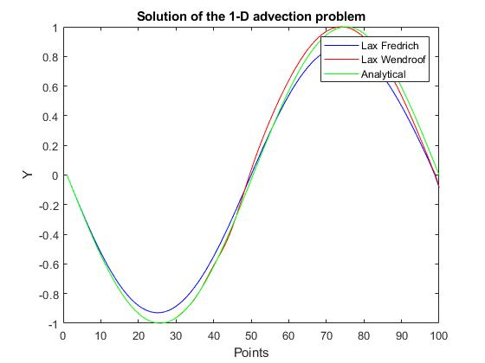

The L1 norm of the error for both solutions compared to the analytical value is:

Lax-Fredrich = 7.3667

Lax-Wendroff = 3.2247

And the reason for the better (lower) value for the Lax-Wendroff is due to it includes artificial diffusion in its method.

**Question 3:**

